WAN Networks

• A WAN is a data communications network that operates beyond (otesinde) the geographic scope (alan, kapsam) of a LAN. While a LAN connects computers, peripherals (elektronik ekipmanlar), and other devices in a single building or other small geographic area, a WAN allows the transmission of data across greater geographic distances.
• WANs use the services of carriers, such as telephone companies, cable companies, satellite systems, and network providers.
• In WANs, there is a common solution use of the virtual channel service (e.g. X.25, Frame Relay, ATM).
• An efficient solution in WANs are also technologies using the existing cable infrastructure (e.g. ISDN, xDSL, cable TV networks) and fixed (sabit) or mobile wireless technologies (e.g. WiFi, WiMAX, radio cell networks).
• WANs often interconnect (birbirine baglamak) LANs.

X.25
• X.25 was defined in 1974 as „Interface between data terminal equipment (DTE) and data circuit terminating equipment (DCE) for terminals operating in the packet mode and connected to public data networks by dedicated (atanmis, ozel, ayrilmis) circuit“. This interface is called user-to-network interface (UNI).
• The internal (ic, dahili) structure of the network can be arbitrary (keyfi, istege bagli) and it is chosen at the discretion (takdir) of communications carriers.
• To organize communications among networks owned by different communications carriers, it is usually necessary to develop a network-to-network interface (NNI), which is often a modified version of UNI.

Characteristics of X.25 Technology
• X.25 is the most suitable for transmitting low intensity traffic.
• Devices called packet assembler-disassembler (PAD) that are intended (tasarlanmis) for assembling (birlestirme) several low speed flows from simple terminals are used.
• A three-layer X.25 protocol stack uses connection-oriented (baglanti yonelimli) protocols at the data link and network layer for controlling data flows and correcting errors. Such redundancy (fazlalik) of functions ensuring reliable data transmission is caused (kaynaklanmak) by the orientation of this technology toward (karsi, yonunde, -e dogru) unreliable communications links.
• Nowadays this technology is obsolete (eski).
X.25 Network Protocol Stack
• Physical layer
- There are two synchronous interfaces (X.21 and X.21bis) to data transmission equipment.
- X.21 – interface to CSU/DSU (Channel Service Unit/Data Service Unit), if the leased (kiralanmis) line is digital.
- X.21bis – interface to a synchronous modem, if the leased (kiralanmis) line is analog.
• Data link layer
- LAP-B (Link Access Procedure–Balanced) protocol, which ensures the possibility of automatic retransmission in case of errors, is used. According to LAP-B, the connection is established between DTE and DCE device.
LAP-B is a connection-oriented protocol that uses the window algorithm for ensuring reliable frame transmission between two directly connected devices. LAP-B is similar to the High-Level Data Link Control (HDLC) protocol.
• Network layer
To establish a virtual end-to-end connection, the X.25/3 protocol is used. Its main function are:
1) packet routing,
2) establishing and terminating virtual circuits between network subscribers,
3) controlling flows of packets.

According to this protocol, the end node sends the call request packet encapsulated (kapsullenmis) into the LAP-B frame. The call request packet specifies (belirtmek) the source and destination address.
The call request packet is received by the network switch and routed according to the routing table, thus creating a virtual circuit. The routing protocol is not defined for X.25 networks, therefore, the routing tables here are always created manually. As the call request packet travels along the route from switch to switch, it makes them generate (olusturmak) new records in switching tables and assign (atamak) them new label values. Thus, a new virtual circuit is created. The initial (baslangic, ilk) value of the virtual circuit number is specified by the user in the Logical Channel Identifier (LCI) field of this packet. After establishing a virtual circuit, the end nodes exchange packets of another format – data packets. In data packets, the source and destination addresses are not specified, and only the LCI label remains (kalmak, arta kalmak) of all address information.

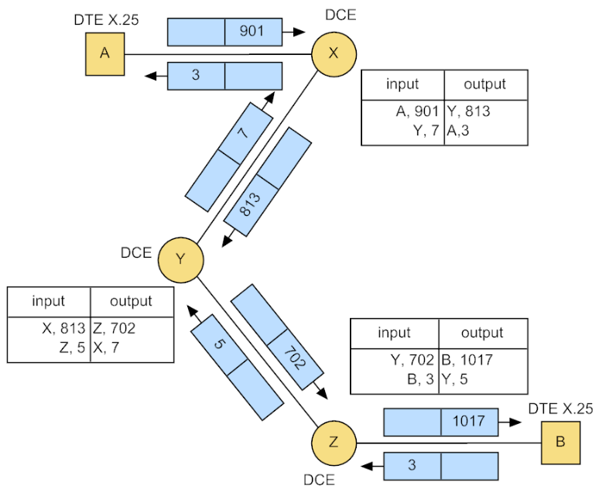
Data transmission in X.25 network

The difference of the X.25 technology from Frame Relay and ATM lines in the fact that it is the network layer technology. Actually, after the virtual circuit is established, the data transmission is carried out (gerceklestirmek) by a network layer protocol instead of a data link layer protocol (as it is in Frame Relay and ATM).

Frame Relay
• Frame Relay is a newer (daha yeni) technology than X.25 and it is far (cok) better suited for the transmission of the bursty traffic typical for computer networks. This advantage becomes obvious (acik, besbelli) only when the quality of communication links becomes comparable to that of LAN communication links. So fiber optic cables are often used in Frame Relay.
• Frame Relay was originally (baslangicta) listed as an add-on (eklenti, sonradan eklenen) of ISDN packet mode services (in 1988). This recommendation (oneri) was revised (gozden gecirilmek, degistirilmek) in 1993.
• Frame Relay standards developed by ITU-T (International Telecommunication Union), ANSI (American National Standards Institute) and Frame Relay Forum define two types of virtual circuits – the permanent virtual circuit (PVC) and the switched virtual circuit (SVC).
• This corresponds (karsilamak) to the user needs because permanent circuits are better suited for connections that constantly (surekli, sik sik) transmit traffic. On the other hand, for connections that are rarely (nadiren) used SVCs are more suitable. However, manufacturers (ureticiler) of Frame Relay equipment and providers of Frame Relay network services support mostly PVCs. Therefore, Frame Relay is often associated (iliskili, iliskilendirilir) only with PVCs.
Frame Relay Protocol Stack
• Frame Relay protocol stack is simpler than the X.25 protocol stack. Because Frame Relay uses high quality communication links, the reliability (guvenirlik) functions are not included. If, despite low error probability (olasilik, ihtimal), errors arise (ortaya cikmak), Frame Relay ignores them, leaving (birakir) all the functions related to recovery of the lost or corrupted (bozuk) packets to higher-layer protocols, such as TCP.
• Because of the low protocol redundancy (fazlalik, yedeklik), Frame Relay is capable of ensuring broad (genis) bandwidth (up to 64 kbit/s in X.25 versus (karsi) up to 2 Mbit/s in Frame Relay) and low frame delays.
• In the Frame Relay protocol stack, the control plane protocols carry out (gerceklestirmek) all operations related to establishing a virtual connection and the data plane protocols transmit frames using the established virtual circuit.
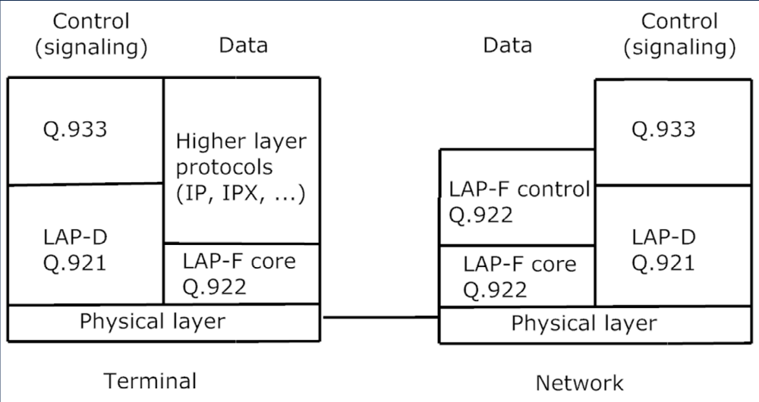
Frame Relay protocol stack

• Link Access Procedure for Frame mode bearer (tasiyici) services (LAP-F) protocol, which in ITU-T recommendations (oneriler) is called Q.922, operates at the data link layer of Frame Relay networks. There are two versions of this protocol:
1) The LAP-F core (cekirdek) provides the minimum set of tools on the basis of which, it is possible to build the Frame Relay network. Such network will provide only PVC services.
2) The LAP-F control must operate in the network if it also provides Frame Switching services. Both LAP-F core and LAP-F control ensure frame transmission between neighboring switches.
• The control plane is responsible for establishing dynamical SVCs. For ensuring the SVC mode, network switches must support two control plane protocols – Link Access Procedure D (LAP-D or Q.921) at the data link layer and Q.933 at the network layer.
- LAP-D in Frame Relay ensures reliable frame transmission between neighboring switches.
- The Q.933 protocol uses addresses of the end node between which a virtual circuit is being established. Usually these addresses are specified in the telephone number format according to the E.164 standard.
• The Frame Relay technology is most frequently (cogunlukla) classified as data link layer technology, where the primary (birincil) attention is paid to the procedures of transmitting user data. Procedures of establishing a virtual circuit are carried out using the network layer protocol.
• Frame Relay virtual circuits can be used for transmitting data of different protocols (e.g. IP packets).
• LAP-F frame contains (icermek):
- DLCI (Digital Link Connection Identifier) – identifies a virtual connection (10 bit - up to 1024 connections -> but it can be enhanced (gelistirilmek) ).

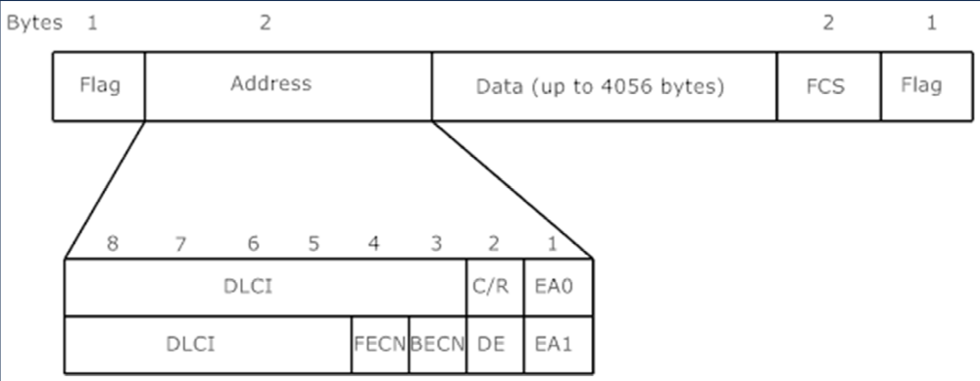
Frame Relay frame

DLCI =
0 … used for LMI virtual circuit,
1 – 15 … reserved (ayrilmis) for future use,
16 – 991 … used by subscribers for numbering PVCs and SVCs,
992 – 1007 … used by network transport services for internal network connections,
1008 – 1022 … reserved for future use,
1023 … used for controlling the data link layer.

- EA (Extended (genisletilmis) address) – if the bit in this attribute is set to 0, the flag is known as EA0 and specifies that the next byte contains the continuation (devami) of the address field; if this flag is set to 1, the field is called EA1 and indicates (gostermek) the termination of the address field.
- C/R (Command/Response) field has the normal meaning like the other protocols from the HDLC family.
- DE (Discard Eligibility (ustunluk) ), FECN (Forward Explicit (belirgin) Congestion (tikaniklik) Notification), BECN (Backward Explicit Congestion Notification) fields are used by the protocol for controlling the traffic and supporting the specified QoS for a virtual circuit.
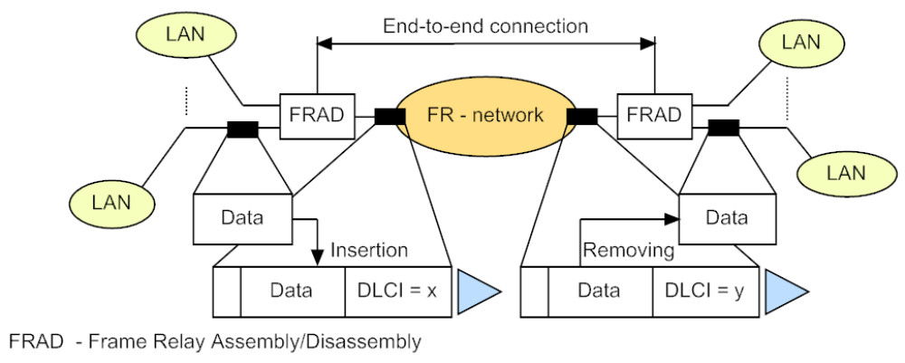
Frame Relay network example

QoS (Quality of Service) Support in Frame Relay
• Frame Relay is able to offer a required transmission capacity to individual virtual connections.

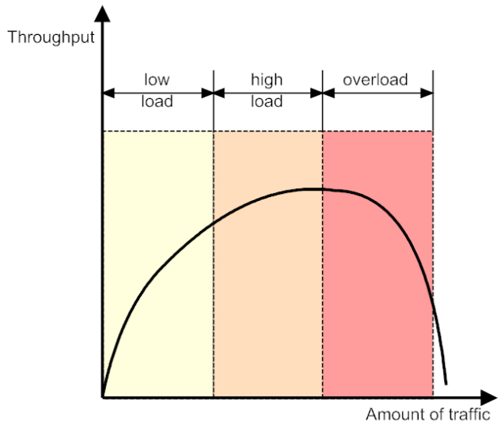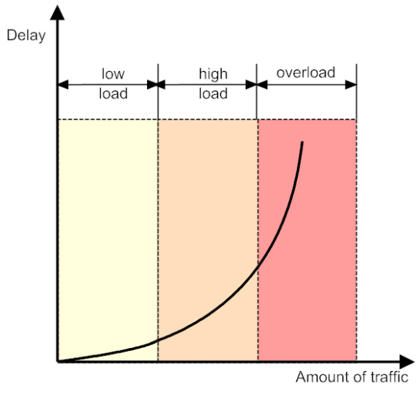
Dependency (bagimlilik) of throughput (cikti, veri) and delay on amount (miktar) of traffic

In the network, it is necessary to have instruments for the prevention (korunma) and, if the prevention fails, for the elimination of congestion (tikaniklik, sikisiklik) states.
• For each virtual connection, several parameters are defined. Each parameter relates to the data transmission rate and influences (etkilemek) QoS.
- Committed (iletilen, islenen) information rate (CIR) – confirmed information rate at which the network will transmit user data,
- Committed burst size (Bc) – confirmed size of the burst (i.e. the maximum number of bytes from this user) that the network will transmit per confirmed time interval T, which is called burst time,
- Excess (fazla, asiri, ilave) burst size (Be) – excess size of the burst that the network will try to transmit in addition to (ek olarak) the agreed Bc value during the predefined T.
• These parameters are unidirectional (tek yonlu), so a virtual circuit can ensure different values of CIR/Bc/Be for each direction.
• If the previously provided values are agreed, then T is defined by the following formula: T = Bc/CIR. As a rule, for controlling traffic bursts, the T interval is chosen to be 1-2 seconds when transmitting data and within the range of several tens or hundreds milliseconds when transmitting voice.
• The main parameter on the basis of which the subscriber and network service provider make an agreement when establishing a virtual connection is the CIR. For PVCs, this agreement is part of the contract for providing network services. When establishing SVCs, the agreement is made automatically using the Q.933 protocol (by (ile) connection request packet).
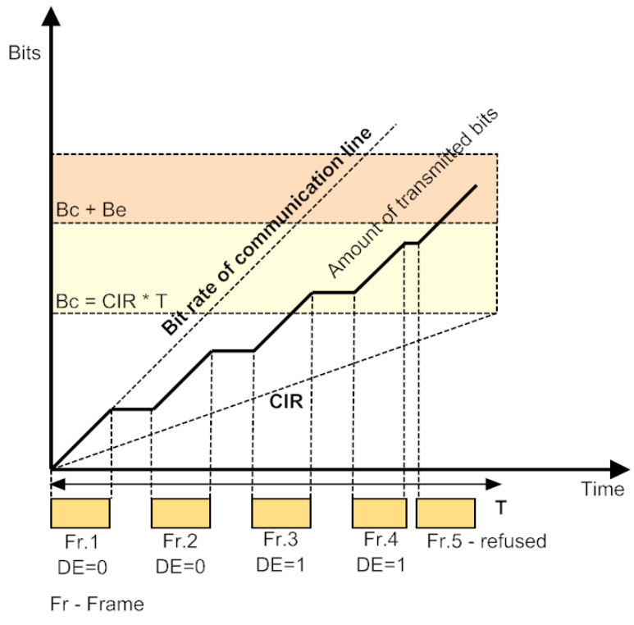
Traffic parameters in Frame Relay
• Frames with the DE (Discard Eligibility (ustunluk, ayricalik) attribute set to 1 will be discarded by the network in case of congestion (tikaniklik).
• Frame Relay technology defines one optional flow control algorithm. This is a mechanism of informing (bilgi verme, ihbar) end users about congestion in network switches (overflowing (dolup tasan) with unprocessed (islenmemis) frames). The Forward Explicit (belirgin) Congestion Notification (FECN) bit informs the receiver about this condition. Based on the value of this bit, the receiver has to inform the transmitter (verici) (using higher layer protocol such as TCP) that it has to reduce the intensity of frame transmission into the network.
• The Backward Explicit Congestion Notification (BECN) bit informs the transmitter about network congestion. It requires the transmitter to reduce the transmission rate immediately.

ATM (Asynchronous Transfer Mode)
• The ATM technology was developed as a universal (evrensel) technology for a new generation of networks with integrated services known as B-ISDN (Broadband Integrated Services Digital Network). ATM was the second attempt (girisim) at building a converged (birlesik) network after ISDN failed to achieve this goal.
• According to the plans of developers, ATM had to be capable of ensuring several of the following capabilities:
- The single transport system for transmitting computer and multimedia (voice and video) traffic, which is highly sensitive to delays, simultaneously. QoS for each kind of traffic has to correspond to its requirements.
- Hierarchy of transmission rates ranging (degisen) from tens of Mbit/s to several Gbit/s with guaranteed bandwidth for critical applications.
- The possibility of using the existing infrastructure of physical links or physical protocols: PDH, SDH or highspeed LAN.
- Interaction (etkilesim) with other protocols, such as IP, Ethernet and ISDN.
• Most of these goals were achieved successfully. Starting from mid-1990s, ATM has been a working technology that ensures the most complete (eksiksiz, tam) and consistent (istikrarli) support of QoS parameters for network users.
• However, ATM has not moved all other technologies out of use and has not become the only transport technology of telecommunication networks. (Bununla birlikte ATM, diğer teknolojileri kullanımdan kaldırmadı ve telekomünikasyon ağlarının tek taşıma teknolojisi haline gelmedi.)
• Development of the ATM standards is carried out by many telecommunication equipment manufacturers (uretici) and communication carriers participating (katilan) in the ATM Forum.

• To utilize (yararlanmak) all features of ATM, the whole network would have to be technologically homogenous. For this purpose, all networks of all service providers would have to support ATM. However, such approach (yaklasim) contradicts (celisir) the main principle of internetworking (aglar arasi iletisim) – each network can support its own technology and the network layer combines these constituent (kurucu) networks into the unified (birlesik) internetwork. Therefore, IP took the dominant (baskin) position at the network layer and continues to be used for the internetworking. IPbased networks are compared to ATM more efficient and cheaper.

Main Principles of ATM Operation
• To speed up switching in large-scale networks, the concept of a virtual path is used. A virtual path connects virtual channels that have a common route in the ATM network connecting the source node and end node or a common part of the route between two network switches. This function also improves ATM scalability (olceklenebilirlik), since it allows considerable (onemli) reduction of virtual connections supported by the backbone router, thus improving the efficiency of its operation.
• ATM is based on the SDH/SONET technology at the physical layer and adopts (benimsemek, kabul etmek) its speed hierarchy. According to this, the starting access rate provided to network users is the STM-1 access rate, which makes 155 Mbit/s.
• ATM backbone equipment operates at higher speeds – STM-4 at 622 Mbit/s and STM-16 at 2,5 Gbit/s. There also exists ATM equipment supporting PDH speed, such as 34 Mbit/s and 45 Mbit/s.
• Data in ATM is transported by cells (ATM PDUs with the fixed length 53 bytes). Using small cells in ATM provides excellent conditions for high-quality service for delaysensitive traffic. The payment for this perfection is the high load on ATM switches when operating at high rates. Amount of work carried out (gerceklestirilmek) by a router or a switch based on any technology is directly proportional (dogru orantili) to the number of packets or frames processed per time unit.
• ATM classification divides all traffic into five classes: A, B, C, D and X. The first four classes represent (temsil etmek) the traffic of typical applications. These applications have a stable (istikrarli, sabit) set of requirements for packet delays and losses. Another distinguishing (ayirt edici) feature of such applications is that they generate (uretmek, olusturmak) traffic characterized by a constant bit rate (CBR) or a variable bit rate (VBR). Class X is reserved for unique (essiz, benzersiz) applications for which the set of characteristics and QoS requirements cannot be classified as belonging to one of the first four classes.
• In the ATM technology, for each traffic class there is a set of quantitative (sayisal) parameters that must be specified by the application:
- peak (zirve) cell rate (PCR) – peak rate of data transmission,
- sustained (surekli) cell rate (SCR) – average rate of data transmission,
- minimum cell rate (MCR) – minimum rate of date transmission,
- maximum burst size (MBS) – maximum size of data burst,
- cell loss ratio (oran) (CLR) – share of the lost cells,
- cell transfer delay (CTD) – cell transmission delay,
- cell delay variation (CDV) – cell transmission delay variation.
• If the support of bandwidth parameters and QoS parameters is not critical for the application, we can omit them by specifying the „best-effort“ attribute in the request for establishing a connection. This type of traffic is known as unspecified bit rate (UBR) traffic.

ATM Protocol Stack
• The ATM protocol stack corresponds to the four lower layers of the OSI model. It includes the ATM adaptation layer (AAL), the ATM layer and the physical layer.
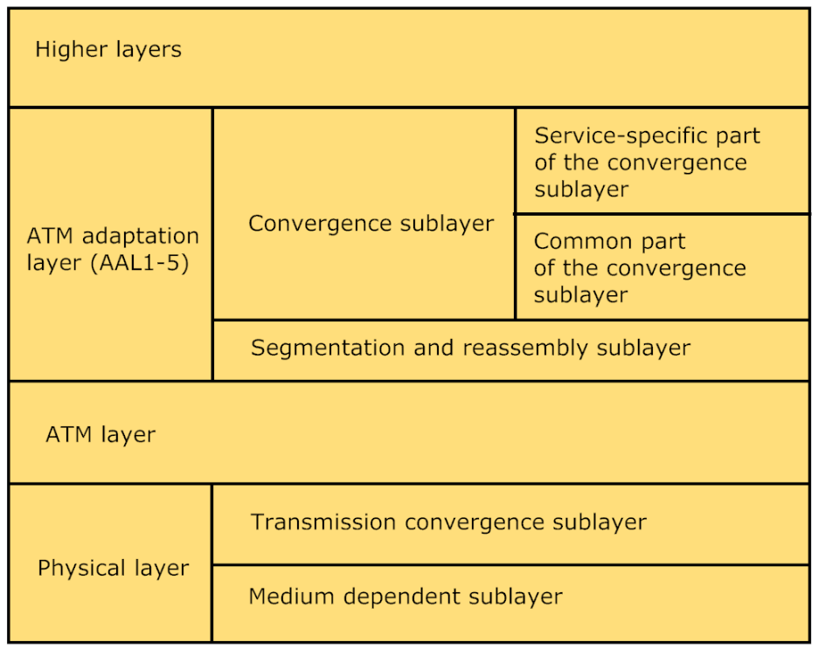
ATM protocol stack

• ATM adaptation layer (AAL)
- The AAL is the set of AAL1 - AAL5 protocols that convert messages of higher layer protocols of the ATM network into ATM cells of the required format. The functions of these layers correspond conventionally (geleneksel olarak) to the OSI transport layer. AAL protocols operate only on network end nodes, like the transport protocols of most networking technologies.
- Each protocol of the AAL layer processes (islemek) user traffic of a specific class:
The AAL1 protocol usually serves Class A traffic with the constant bit rate which is typical for digital video or voice and is sensitive to delays. ATM networks transmit this traffic so that it emulates (taklit etmek) normal leased (kiralanmis) digital links.
The AAL2 protocol was developed for transmitting Class B traffic. Later, it was excluded (cikarilmak) from the ATM protocol stack.
The AAL3/4 protocol processes bursty traffic typical for computer networks. This is a variable bit rate traffic and it is processed so that cell losses are prevented (hücre kayıplarının önlenmesi için). However, cells can be delayed by the switch. It is used for Class B traffic.
The AAL5 protocol is a simplified version of the AAL4 protocol. It operates faster because it does not compute the checksum for each cell of the message. Instead of this, it computes the checksum for the entire source message and places it into the last cell of the message. It is normally used for computer data traffic (Class C and D). AAL5 operates not only on end nodes but also on ATM switches where it supports establishing of virtual connections.
- The convergence (yakinsama) sublayer (CS) depends on the class of traffic being transmitted. It solves such problems as ensuring synchronization between transmitting and receiving nodes and the error control of user data. Recovering lost data is a task delegated (devredilen) to higher layer protocols that are not included into the ATM protocol stack.
- The segmentation (bolunme) and reassembly (SAR) sublayer does not depend on the AAL protocol type. It segments (bolmek) the message received by AAL from the higher layer protocol. After creating ATM cells, SAR supplies them with headers and passes them to the ATM layer for transmitting into the network.
• ATM layer
- The ATM layer transmits cells using switches when the virtual channel is established and configured, which means that this task is based on the switching tables.
- The ATM protocol carries out switching using the number of the virtual channel, which is split into two parts – virtual path identifier (VPI) and virtual channel identifier (VCI).
- ATM switches can operate using two modes:
1) virtual path switching – The switch forwards the cell only on the basis of VPI and ignores VCI. One virtual path corresponds to the set of aggregated (toplu) virtual channels. The backbone switches of large scale regional networks usually operate in this way.
2) virtual channel switching – After delivering (iletim) the cell to the local ATM network, the switches of that network start switching cells taking into account (dikkate alarak, hesaba katarak) both VPI and VCI (without the modification of VPI).

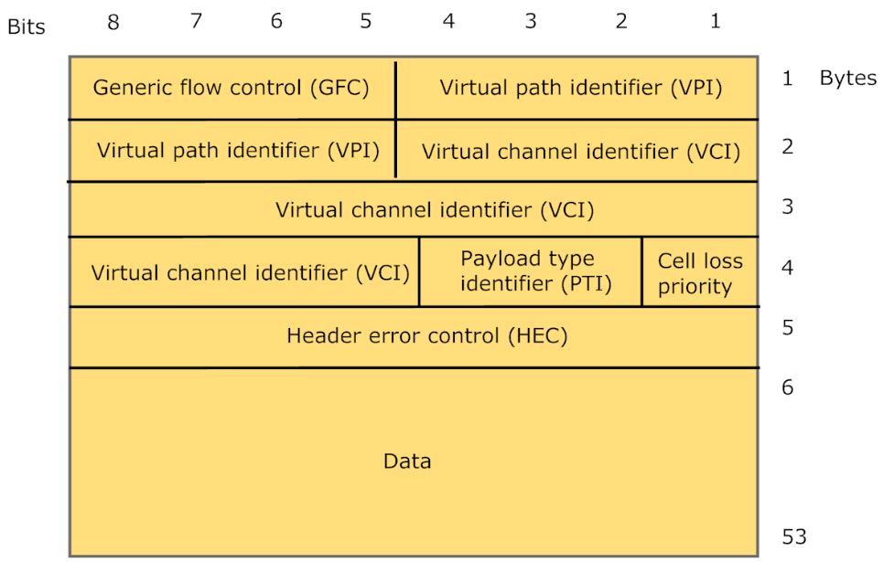
ATM cell format

- The ATM cell format:
Generic flow control – is used for the flow control on the user-to-network interface.
Payload type identifier – specifies the type of data carried by the cell (user data or control data). Furthermore, 1 bit of this field - the explicit (acik, belirgin) congestion (tikaniklik) forward identifier - is used to indicate network congestion. It works like the FECN bit in the Frame Relay technology.
Cell loss priority – plays the same role as the DE field in the Frame Relay technology. ATM switches use this field to mark (isaretlemek) the cells that violate (ihlal etmek) the agreement of the QoS parameters of the connection. Such cells will be discarded if network congestion occurs.
• To establish switched virtual connection, a separate protocol has been developed – Q.2931. It relies on (dayanmak) a sophisticated (gelismis) protocol named SSCOP, which ensures reliable transmission of Q.2931 messages. SSCOP operates over the AAL5 protocol.
• The end node uses the call setup packet of the Q.2931 protocol to request establishing a virtual connection and to specify traffic parameters and QoS requirements. When such packet arrives to the switch, the switch must analyze these parameters and decide if it has sufficient performance resources for serving a virtual connection. If so, then a new virtual connection is accepted and the switch passes the call setup packet according to the destination address and routing table. If available resources are insufficient, the request is denied (reddedilir).

